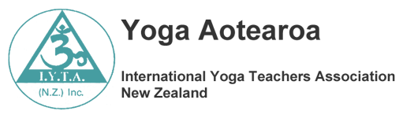

Inspiring Unity through Yoga

Information Brochure
On Yoga Aotearoa/IYTA and the education courses it offers

The Association is for anyone interested in Yoga – that’s you!
We aim to make educational courses available to anyone anywhere in New Zealand

For more information on our aims, membership and our courses please visit our web site www.iyta.org.nz
and find the local branch nearest to you.

Yoga Aotearoa/IYTA (NZ) Inc.
About us:

Yoga Aotearoa/ IYTA (NZ) Inc. is a not-for-profit incorporated society and registered charity. As such, it is open for all who wish to travel the Yoga journey, be they students or teachers.
We use Yoga Aotearoa as our day-to-day name.
In this brochure we will abbreviate Yoga Aotearoa /IYTA (NZ) Inc. to IYTA
We do not have an affiliation to any school which allows us the freedom to teach an integrated style of classical yoga.
IYTA offers on-going courses in learning about, and teaching, Yoga. We are committed to providing courses of excellence. Our graduated teachers have an in depth grounding in the classical basis of Yoga, and this is integrated into their classes. They bring balance and variety into their programmes.

IYTA presents for its members a Biennial Yoga Convention. This is held in a variety of centres throughout New Zealand.

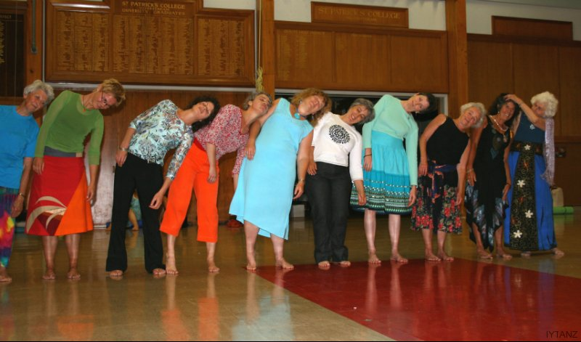

Next Yoga Aotearoa/ IYTA (NZ) Inc. Convention:
2019
For further details:
www.iyta.org.nz
Yoga Aotearoa /IYTA (NZ) Inc
Courses
Overview:
Our Vision: To inspire unity through yoga
Our Mission: To provide learning experiences in Yoga which:
- Honour the Yoga philosophies of original texts
- Provide a transformative path to health, wellbeing and oneness
- Are relevant, broadly based and inclusive
- Raise consciousness
- Heighten awareness of contemporary research and theories of Yoga

The Principles which provide the foundation of all our courses:

- Philosophical base:
The Eight Limbs of Patanjali’s Sutras

- Course presentation:
Inclusive, designed to meet individual student learning needs through a mix of both face-to-face and online delivery throughout Aotearoa New Zealand.

- The Map of Meaning designed by Marjolein Lips-Wiersma:
Guides the delivery of each course, encouraging balance and self-reflection.

- Values:
IYTA is inclusive of the values the strengths, experiences and interests of all, both learners and teachers, who are on their yoga journey.

- Excellence: Teachers and tutors of all courses have successfully completed the IYTA Teaching Diploma and are committed to providing positive support to student

Overview of YOGA AOTEAROA/IYTA (NZ) Inc. Courses offered 2018-2019
All courses are structured according to ‘The Map of Meaning ’Marjolein Lips-Wiesma
Title | Introduction to Yoga | Teaching Diploma | Advanced teaching -Tutor course | Continuing Professional Development (CPD) | Continuing Personal development
Level | 1 | 2 | 3 | 3 | 1,3
Co-requisites, prerequisites | None except an interest in Yoga | Commitment to yogic life style. Completion of the questionnaire on the student’s involvement with yoga in the enrolment form.  Acceptance of the IYTA code of ethics.  Acceptance of the requirements of the course.  Current IYTA member | Completed the IYTA Teaching diploma or a yoga teacher training course approved by the IYTA executive committee  Have submitted an application to become an IYTA tutor.  Current IYTA member. | Completed a Yoga Teaching Diploma or equivalent.  Teaching yoga  Current IYTA member | An interest in yoga  Current IYTA member
Course delivery mode | Face to face + home assignments | Paper based or on line + tutorial system | Face to face + home assignments | Face to face or on line | Face to face or on line
Length | 3 months | 18 months | 3 months | 1 day to 3 months | Varied
Delivery mode | One Workshop and 3 one monthly assignments | Four workshop and 15 home based assignments (correspondence) | One workshop and monthly assignments | Workshops and assignments | Workshops
Course description | This course is designed to give a broad introduction to classical Yoga. | This course is designed for those wishing to teach Yoga to the general public. | This course is designed for members of IYTA who have indicated an interest in a tutor’s role on courses offered by IYTA. course. | These courses are designed to further Yogic knowledge for those who are in the teaching profession.  See note below.* | These courses are designed for general interest to anyone interested in Yoga.
Assessment:  - Non graded  - Completion  of each aspect to a certain standard  - Portfolio  - Journal  - Annotated bibliography | - Non graded but tasks must be presented to an acceptable standard | 1.Non graded but tasks must be presented to an acceptable tertiary standard  - Each assignment task is given a pass or a re-submit. A re-submit must be completed before the next assignment  - Portfolio will be presented for final viewing at the last workshop. Annotated bibliography by 20th Sept.  - Presentation of a yoga lesson to a community class is observed and assessed by an accredited IYTA teacher | Assessment of assignments. | Not graded but tasks must be presented to an acceptable tertiary level. | Not graded but tasks must be presented to an acceptable level.
Costs  Required texts  Recommended texts | $680 if paid on enrolment, includes weekend accommodation, tuition and text, YA membership but excludes travel.  Or $350 non-refundable deposit on enrolment, balance $380 before 18th April 2018 | $4200.00 (includes assignments and all four workshops – food accommodation and tuition  YA membership but excludes travel and text books.  $1050 deposit payable on enrolment  $300 discount for those completing the 2018 min-course | No tuition cost but cost of weekend accommodation food and transport to venue | Varied | Varied
Next course | To be arranged | March 2019 | To be arranged | See website | See website

* IYTA teaching members are expected to undertake ongoing professional development. This might be through IYTA or though any formal course of the individual’s choice. Such learning experiences should be chosen to enhance Yoga teaching.
Introduction to Yoga Mini Course

Title | Introduction to Yoga Mini Course
Course description | This course is designed to give a broad introduction to classical Yoga.
Aim | To enable students to understand the fundamental principles of Yoga
Learning outcomes | By the end of this course students will have an understanding of:  - The meaning of Yoga  - The fundamental principles of Patanjali’s Sutras  - Insights into the nature of higher consciousness
Content | What is Yoga  Nature of higher consciousness  - History of yoga  - Basic Sanskrit  - Styles and paths of yoga  - Classic texts of yoga  Sutras: Patanjali , the eight limbs  - Yama and Niyama  - Asana  - Pranayama  - Pratyahara  - Dharana,  - Dhyana.  Yoga Nidra.  Chakras  Sadhana
Requirements  To meet the learning outcomes of this course you are required to : | Attend the Introduction to Yoga weekend and to the satisfaction of the tutors , complete three monthly assignments
Course Review | This course is subject to regular appraisal in light of tutor and student evaluation.
Certification | Certificate of participation
Minimum numbers to run course | 12

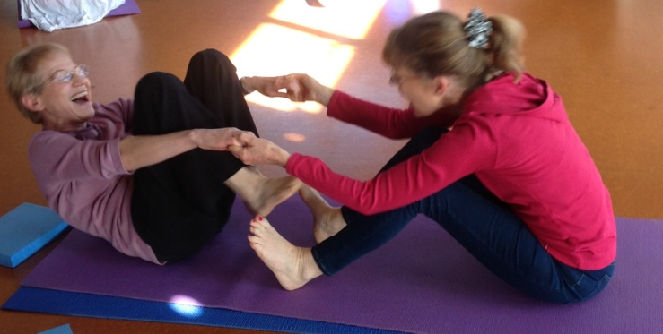
Teaching Diploma Course

Title | Teaching Diploma Course
Course description | This course is designed for those wishing to teach Yoga to the general public.
Aim | To enable students to extend their personal and professional knowledge and understanding of the principles and practice of Yoga in a safe and professional manner.
Learning outcomes | By the end of this course students will demonstrate:  - In depth understanding of the key concepts covered in the strands  - Apply this understanding to designing and teaching at workshops and teaching a class from the community to the satisfaction of an allocated IYTA observer  - Comprehension and application of the strands as listed under contents
Content | Anatomy and physiology  Asana  Health and Wellbeing  Inner disciplines  Pranayama  Philosophy and History  Portfolio/ Research  Sanskrit and Sound  Teaching
Requirements  To meet the learning outcomes of this course you are required to : | Present and pass fifteen monthly assignments  Attend and participate in all four compulsory workshop weekends  Plan and teach aspects of yoga to peers at workshops  Teach a minimum of 60 hours of yoga in the community which is observed and assessed by an accredited IYTA teacher  Present a portfolio and annotated bibliography of 5 to 10 books on an approved Yoga topic  Hold a current comprehensive workplace first aid certificate
Course Review | Both at the end of course regular review by tutor and student evaluation during the course.
Certification | IYTA Teaching Diploma – IYTA Dip. May be officially used after graduation for advertising purposes. CPD and membership must be maintained for this entitlement.
Minimum number | 20
Advanced Teaching – Yoga Tutor Course

Title | Advanced Teaching -Tutor course  (Starts 2014)
Course description | This course is designed for members of IYTA who have indicated an interest in a tutor’s role on the Teaching Diploma course or any other IYTA course.
Aim | To enable participants to further develop their teaching and communication skills in preparation for a role as an IYTA tutor.  Foster higher consciousness
Learning outcomes | By the end of this course students will:  - Have furthered their teaching skills  - Be able to teach in the Introduction to Yoga Mini Course  - Be able to be a Teaching Diploma tutor for IYTA  - Present CPD modules for IYTA  - Have designed a CPD module of personal interest to offer in their community
Content | How to be an effective tutor  Review the contents of the IYTA Teaching Diploma Course  Developing Portfolios  Assessing assignments  Techniques for working with groups  Collaborative planning  Presentation of workshop sessions  Course design  Administration responsibilities
Requirements  To meet the learning outcomes of this course you are required to : | Attendance at the workshop.  Complete any allocated assignments to the satisfaction of the organising tutors. e.g. design short CPD course  A willingness to assume a role of tutor on IYTA courses
Course Review | This course is subject to regular appraisal in light of tutor and student evaluation
Certification | Certificate of Advanced Teaching – Yoga Tutor Course IYTA
Minimum number | 6
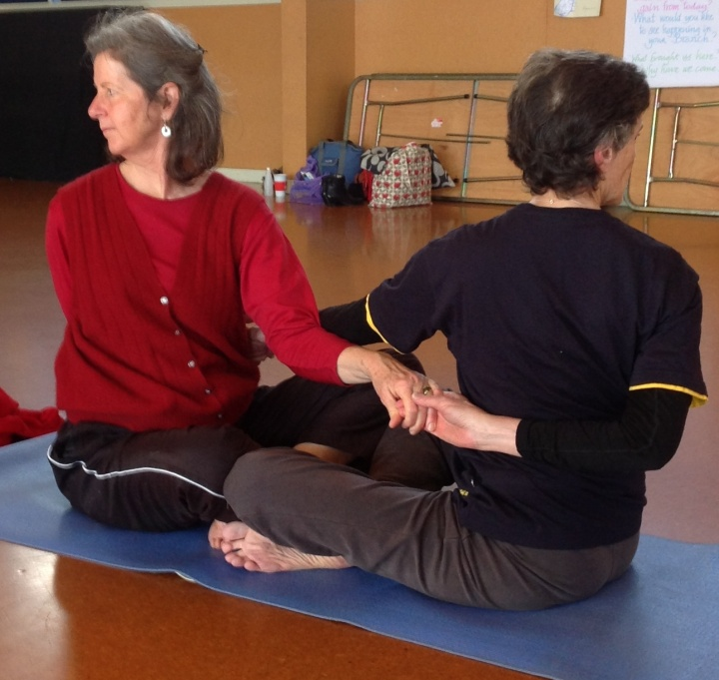
Continuing Personal Development

Title | Continuing Personal development
Course description | A course designed for general interest to anyone interested in Yoga.
Aim | To enable students to further develop their theoretical and applied knowledge and understanding of Yoga.
Learning outcomes | Have a heightened understanding and knowledge of contemporary research and theories of Yoga.
Content | Varies according to the learning experience undertaken
Requirements  To meet the learning outcomes of this course you are required to : | Attendance of the whole course.  Complete any assignments to the satisfaction of the tutor.  Students are encouraged to keep a log sheet of their learning.
Course Review | Self-evaluate

Continuing Professional Development (CPD)

Title | Continuing Professional Development
Course description | These courses are designed to further Yogic knowledge for those who are in the yoga teaching profession.
Aim | To enable students to further develop their theoretical and applied knowledge and understanding of Yoga in their teaching practice.  To share their understanding within IYTA.
Learning outcomes | By the end of these courses students will demonstrate:  A heightened understanding and knowledge of contemporary research, theories and practices of Yoga for applying in teaching yoga
Content | Varies according to personal choice
Requirements  To meet the learning outcomes of this course you are required to : | Attendance of the whole course.  Complete any assignments to the satisfaction of the tutor.  Include documentation on the IYTA log sheet (find under membership on iyta.org.nz web site)  N.B. All students graduating from 2014 on are required to send their log sheet in with their membership renewal form to the membership secretary rosemaryweaver@xtra.co.nz
Course Review | Self-evaluate
Certification | Certificate of participation or formal documentation related to course.
The Map of Meaning
Yoga Aotearoa IYTA (NZ) is privileged in being encouraged by the authors to use this Map as a framework for each and all of our courses. Unlike many ‘self help’ books, the Map of Meaning is the result of rigorous academic research and ongoing review. While the Map was designed with an emphasis on the world of work, the ‘lived’ experience of Yoga makes a natural ‘fit’ with its clear, simple yet profound dimensions.
Some Key Elements of the Map of Meaning.
There are three main aspects to the model.
The first is the four pathways to meaningful work: this shows us that human beings find meaning through the fulfilment of these four aspects of their lives. These are: Developing the Inner Self, Unity with Others, Service to Others, and Expressing Full Potential.
Second, these four pathways are held in tension by apparently opposing desires, the drive to meet the needs of the Self and the need to meet the needs of Others; and the need for Being (reflection) as well as the need for Doing (Action).’
Third, all these elements are played out in the overall context of Inspiration and the Reality of our Self and our Circumstances.
The Four Pathways:
Developing the Inner Self:
At the heart of this pathway is the idea that an unexamined life is not worth living, and who we become as a result of being engaged in work, and in other parts of our lives, greatly matters to us as human beings.
Unity with Others:
At the heart of this pathway is understanding that humanity is essentially one and that experiencing this is what enriches our humanity
Expressing Full Potential:
At the heart of this pathway are the concepts that we are all unique, and that we are responsible for bringing our unique gifts and talents to the world.
Service to others:
(At the heart of this pathway) is the human need to make a contribution to the wellbeing of others, from helping an individual to making a difference in the wider world.
Lips-Wiersma, M. And Morris, L. ‘The Map of Meaning: A Guide to Sustaining our Humanity in the World of Work’ (2011) Greenleaf Publishing.
For further information on The Map of Meaning: see: www.holisticdevelopment.org.nz

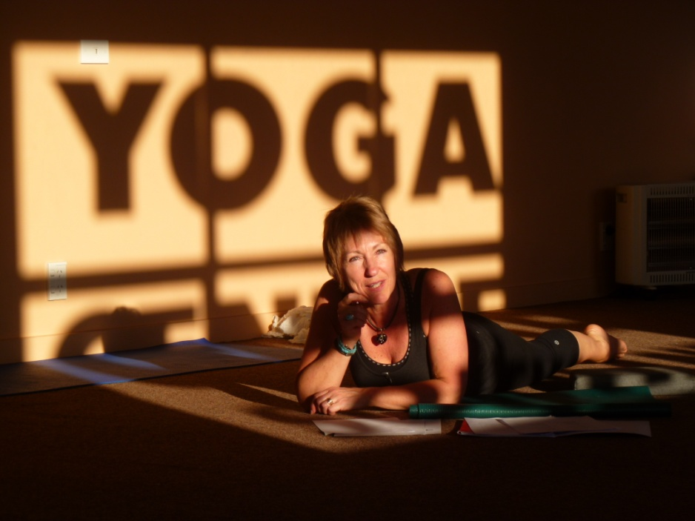 Southland Yoga Studio
Yoga Aotearoa- Professional Development Log sheet 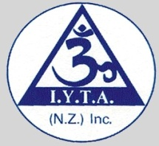

Name: year: 201_ Sheet No ____ of _____
 | 1.Date and  location | 2. Description of Professional development. | 3. Quadrants of Map of Meaning* applicable | 4. Duration hours or days | 5. PD Category  A,B,C or D
1
2
3
4
5
6
7
8
Current First Aid certificate Yes/No

* Map of Meaning copyright of Marjolein Lips Wiersma

1. Date and location. Please fill in the date or dates of the course/s attended or service offered and location.
2. Description of Professional development. Give the title of the course and who was leading it or area of service offered e.g. 3 hours attending branch committee meeting.
3. Quadrants of Map of Meaning are: developing the inner self, unity with others, service to others, expressing full potential.
4. Duration. Number of hours/days of participation
5. PD category:
A YA/IYA Courses Attending courses offered by YA/IYTA
B Participation Attending workshops, course, seminars, conventions, research, or written observations of colleagues’ teaching practice.
C Related Studies Recognition of studies that enhance your yoga teaching
D Service to the yoga community
* Please refer to the Autumn Newsletter 2013 for information on the Map of Meaning by Marjolein Lips Wiersma
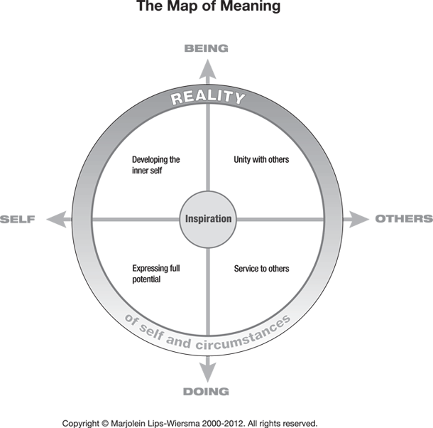

The log sheet is for you to fill in for your own Professional development records. If you are completing a Yoga Teacher Training Course or the IYTA Teaching Diploma course, we would like you to send a copy of this with your membership fees from 2014 onwards.

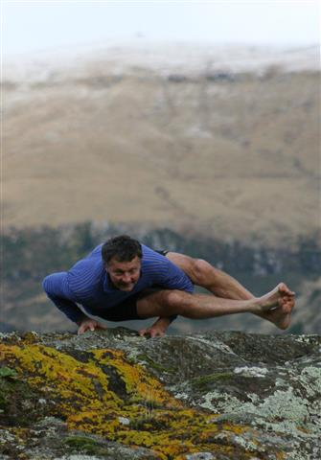

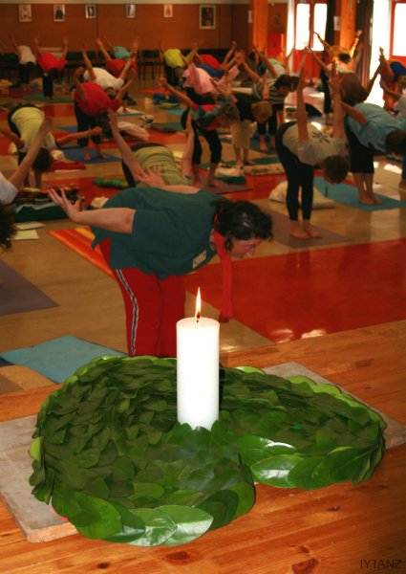

How to Contact us
For details of news, course and events check out our website
www.iyta.org.nz
Or
Contact your local branch representative
Otago Southland
Linda Ryder lindayoga4u@gmail.com
John Guthrie johndominique2@gmail.com
Canterbury Tasman
Rosemary Weaver rosemaryweaver@xtra.co.nz
Mark Bloomberg mark.bloomberg7@gmail.com
Wellington and Lower North Island
Jill Faulkner jillpeepoday@inspire.net.nz
Susan Kirkham kirkham@actrix.gen.nz
Auckland and Upper North Island
Isobel Murphy manawarereps@gmail.com
Helen Kerrison

Teaching Diploma Coordinator
Amanda Percival info@yogabyamanda.com

Membership costs $57. To join visit www.iyta.org.nz or:

Ask your local IYTA teacher for a membership form or:
Contact a branch representative above.

